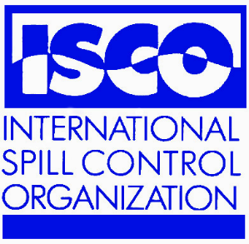
ISCO NEWSLETTER

Issue 114 28th January, 2008

Email info@spillcontrol.org Web http://www.spillcontrol.org

Cyprus and Syria Sign Cooperation Agreement on Maritime Pollution
Approximately a year and a half after a direct hit by Israeli warplanes on a coastal power plant in Lebanon released as much as 17 million liters of fuel oil in the Mediterranean Sea in July 2006, Cyprus and Syria signed a cooperation agreement on combating maritime pollution. The agreement was signed at the conclusion of the two-day Syrian-Cypriot Committee Meeting on Sunday, January 13. A SANA article also describes the agreement fully: "At the conclusion of the meeting of the Syrian-Cypriot Committee Sunday, the two sides agreed on combating marine pollution, training and rehabilitation, research and rescue and the possibility of holding twining among the Syrian and Cypriot ports as well as coordinating stances in the international Maritime Organization (IMO)." Apparently, Cyprus also ". . . expressed readiness to offer technical support to the Syrian side in the field of training cadres in accordance with the criteria of IMO." [Thanks to ISCO Executive Committee Member Dan Sheehan for forwarding this item from the MarEx Newsletter]

HOMELAND SECURITY : US NATIONAL RESPONSE FRAMEWORK
The National Response Framework supersedes the National Response Plan and more adequately serves as a guide to how the nation conducts incident response. The new name better aligns the document with its intent. Its purpose is to ensure that government executives, private sector, nongovernmental organization (NGO) leaders, and emergency management practitioners across the nation understand domestic incident response roles, responsibilities and relationships in order to respond more effectively to any type of incident. With a broader scope the Framework provides structures for implementing national-level policy and operational coordination for domestic incident response. In this document, incidents include actual or potential emergencies or all-hazard events that range from accidents and natural disasters to actual or potential terrorist attacks. Such incidents range from modest events wholly contained within a single community to others that are catastrophic in nature and national in their scope of consequences. The Framework is intended for executive leadership and emergency management practitioners at all levels of government, as well as private sector, and nongovernmental organizations (NGOs). The Emergency Support Functions and Support Annexes have been updated and remain an integral part of the Framework. ESF #10 provides for a coordinated Federal response to actual or potential oil and hazardous materials incidents. Response to oil and hazardous materials incidents is generally carried out in accordance with the National Oil and Hazardous Substances Pollution Contingency Plan (NCP), 40 CFR Part 300. For purposes of this annex, “hazardous materials” is a general term intended to mean hazardous substances, pollutants, and contaminants as defined in the NCP. Hazardous materials include chemical, biological, and radiological substances, whether accidentally or intentionally released. http://www.fema.gov/pdf/emergency/nrf/whatsnew.pdf [Thanks to Ed Costiuk of Hazmat 101 Group for forwarding this news item]

Interspill 2009 at Marseille
Every 3 years, Interspill hosts the world’s leading experts in oil and chemical spill prevention, preparedness, response and restoration. In 2006 London was host for this now well established conference and exhibition and in 2009 it will be held in Marseille. In 2009, Interspill will not only bring together the oil industry, the spill industry, governments and international agencies, but the 4th IMO R&D Forum will be held at the same time, bringing representatives of many nations concerned with the Marine Environment. This combination underlines the conference theme, Working Together, which has improved prevention and lead to better response, and restoration of spills over recent years from greater cooperative efforts. The 2009 Interspill conference and exhibition will be held on 12 - 14 May 2009, at the Parc Chanot in Marseille, France. The event is expected to attract over 1000 visitors and delegates, from 70 nations and more than 100 companies will exhibit the latest advances in oil spill technology and solutions. The event is organised by Intelligent Exhibitions and the European Spill industry together with IPIECA, representing the international oil industry, and EMSA representing the EU. http://www.interspill.com

Gulls' blood records oil impacts

Seabirds' blood can hold vital clues about the long-term ecological impacts of oil spills, researchers suggest. Scientists collected samples from gulls in north-west Spain, close to where the Prestige tanker sank in November 2002. Seventeen months after the disaster, concentrations of toxic compounds in the birds' blood were, on average, 120% higher than normal. The team hopes its findings will offer a way to collect data about oil spills' accumulative effect on wildlife. Writing in the American Chemical Society's journal Environmental Science and Technology, the Spanish scientists explained why seabirds could be considered good "bioindicators" of lasting pollution.
http://news.bbc.co.uk:80/1/hi/sci/tech/7181910.stm

HIGH IMPACT 3D TRAINING PIONEER SEEKS JV PARTNER FOR EMERGENCY SPILL RESPONSE TRAINING
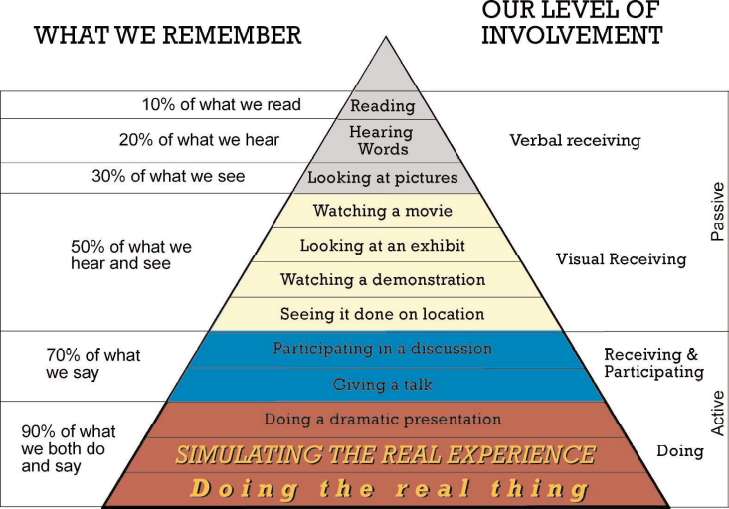
Michigan-based 3-D ETC Inc. has pioneered a unique on-site training system that utilises 3-D high definition video with stereo sound to deliver a high impact immersive training experience. According to the model, workers attending a safety training seminar with these elements alone will retain only 10% of what they learn. Movies, exhibits and television increase retention to 50%, enough for passive learning but insufficient to affect what participants say and do on the job. In order to truly affect message retention and change behavior, learners must experience a simulation that comes as close as possible to the real thing. By using the 3-D immersive training technique, simulating real experience exposure, retention of teaching exceeds 90%. The training content is given unsurpassed vividness and impact. Students undergo a powerful hour-long facilitated program delivered through special headsets that display both 3-D imagery and binaural sound. To build each program, 3-D ETC crafts the message by first learning and assessing its clients’ needs and then applies its learning template to deliver a solution. To date, the system has been applied mainly to safety training with impressive results. In 2003 the US Department of Defense challenged all its facilities to reduce on-the-job accidents by 50 percent within two years. 3-D stereoscopic immersive training has proved itself as a key resource for achieving this objective. Rick Garver, chief of safety and health for the Defense Logistics Agency commented “This learning system helped workers assimilate faster and more permanently.” Training providers interested in applying the system to emergency spill response training should contact Dave Hodgson at dave.hodgson@3-detc.com or Ray Nelson at ray.nelson@3-detc.com

Legal disclaimer: Whilst ISCO takes every care to ensure that information published in this Newsletter is accurate, unintentional mistakes can occur. If an error is brought to our attention, a correction will be printed in the next issue of this Newsletter.

