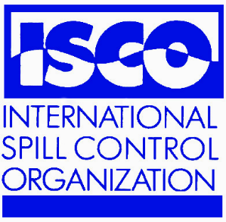
ISCO NEWSLETTER
The Newsletter of the International Spill Response Community

Issue 179 11th May, 2009

Email info@spillcontrol.org Web http://www.spillcontrol.org

SPECIAL INTERSPILL 2009 EDITION

FIND OUT WHAT’S NEW AT INTERSPILL 2009

THE ANNUAL GENERAL MEETING OF ISCO WILL BE HELD AT 3 PM ON WEDNESDAY 13th MAY, 2009, IN THE SALLE RATONNEAU AT THE INTERSPILL CONFERENCE AT MARSEILLE, FRANCE.


Kurt A. Hansen, P.E., of the United States Coast Guard Research & Development Center will be the Guest Speaker at the ISCO 2009 AGM.

We hope to see as many ISCO members as possible and an invitation is extended to interested non-members to come along to the meeting.

The Salle Ratonneau is on the 3rd floor of the Parc Chenot Exhibition and Conference Centre.

RO-CLEAN DESMI LAUNCH A BRAND NEW SKIMMER
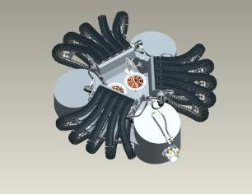
ISCO Member RO-CLEAN DESMI is proud to announce the launch of its brand new skimmer, the "DESMI GIANT OCTOPUS”, which will be available for you to view here at the show. This revolutionary ultra high capacity offshore skimmer features a new way of collecting the oil, and is able to collect oil from a 360 degree area, due to the fact that there are no outlying floats to block the flow of the oil.

The patented skimmer design has a highly efficient belt brush recovery system and 15 belt/brushes in 3 modules of 5. The skimmer is a development from our popular TARANTULA and HELIX skimmers. It also features two DOP-250 DUAL pumps to handle the large volume of oil this skimmer is capable of recovering.

Please visit RO-CLEAN DESMI on stand number 309 in the main exhibition hall to see the revolutionary new “DESMI GIANT OCTOPUS” skimmer.

BRIGGS PIONEERS NEW APPROACH TO HNS RESPONSE CONTINGENCY PLANNING

ISCO members Briggs Environmental Services Ltd. and Alpha Briggs Mediterranean Ltd. have broken new ground in the development of oil and chemical pollution response contingency planning.

The term HNS embraces thousand of different chemicals that may react with air, or water, or with each other, and in themselves, or in reaction, present a very wide range of hazards and pollution effects. To attempt to cover detailed response recommendations for so many varieties of HNS within a manageable-sized spill contingency plan has so far been completely impossible. Most plans produced to date only give generic guidance to HNS response.

In a new marine oil and chemical spill contingency plan produced for an overseas government, Briggs has made use of links to web-based sources of reference information, an innovation that facilitates rapid access to a vast reservoir of additional data that could not be contained within a conventional contingency plan. In this way, users of the plan are able to home in on information that is specific to the kind of spill encountered – with excellent implications for safe and effective response.

The potential benefits of web-based information sources were recognized in discussions at last year’s IMO OPRC-HNS Technical Group Meetings in London and the application to contingency planning is an important new development.

You can learn more about this by visiting Briggs at stand number 235.

FURTHER DEVELOPMENT OF THE ASTM SKIMMER TEST PROTOCOL AND THE REMARKABLE NEW SKIMMER TECHNOLOGY FROM CRUCIAL

Representatives of Ohmsett, S. L. Ross and the U. S. Coast Guard will be making a presentation on the latest Phase 2 developments of the American Society of Testing and Materials (ASTM) stationary skimmer test protocol on Tuesday 12th May at 1600 hrs. in the Endoumes Room at Interspill.

One of the first skimmers tested under the new protocol was Crucial’s new coated disc skimmer and Wally Landry has provided information about this remarkable new technology.
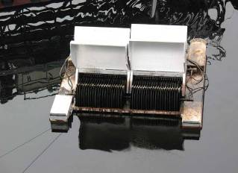
Crucial has just completed a successful 18 month R&D project on the coated disc skimmer concept. This utilizes a fabric covered disc skimmer system that multiplies the oil recovery rate by 500% over traditional smooth drum or disc surfaces. Tested using the new ASTM Test Protocol, the new skimmer achieved the highest pure oil recovery rate of any oleophilic skimmer in the history of the OHMSETT Test Facility in New Jersey. The new technology is now available in both inshore disc and drum skimmers up to large offshore skimming systems. The new skimmer can be integrated with existing stockpiles of umbilical cord deployment systems or V-sweep booms or ocean buster type concentrating systems.
You can get more information and meet up with Wally Landry on the Selwood Pumps stand number 270.

ALPINA BRIGGS DEVELOPS VOLUNTARY ENVIRONMENTAL AGENTS TRAINING

ISCO Member Alpina Briggs Defesa Ambiental S/A along with its main client are the founders of this type of training for communities living in high risk areas with it’s objective being that in the event of an oil spill they can be called upon to assist during cleanup operations.

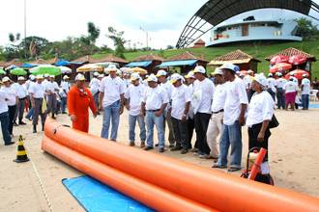
The course has been designed and simplified to show the basics of shoreline cleanup operations with the emphasis focused on health and safety, containment and recovery techniques, disposal and decontamination procedures.

Each participant on entry fills out an application form with all of his/her contact details, and these are stored on a data base. Before the course they all carry out a basic medical evaluation to check that they are medically fit to carry out such work.

Large scale clean-up operations often involve huge amounts of manpower. Response time and trained personnel are critical in a successful clean-up operation. Having a database of trained workers strategically placed around the country greatly improves in the initial response.

In the North of Brazil (Amazon Area) over 17 courses have been carried out, training over 1500 people. Due to the remoteness and lack of facilities in these areas it would not be possible to transport large amounts of workers to assist in clean-up operations, making it more practical to train the locals living in the area. In total over 4000 people have been trained in Brazil and a further 940 people internationally in Mexico, Argentina and Equador.

This new development will be the subject of a poster presentation by Marcela Lopes Calor of Alpina Briggs Defesa Ambiental SA, Brazil. Poster presentations are manned by the presenting author on Tuesday 12th May from 12.15 pm to 1.30 pm and again on Wednesday 13th May from 12 pm to 1.30 pm. All the poster presentations are located on level 1 of the exhibition.

NEW “WASTE MANAGEMENT CALCULATOR” JOB AID

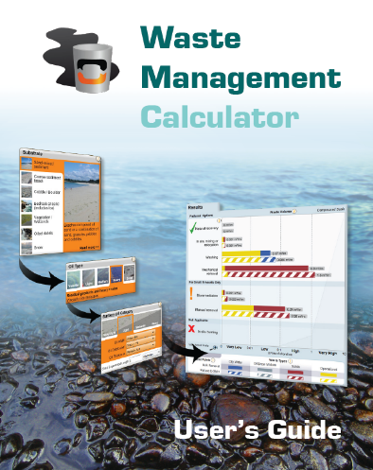
The Emergency Prevention, Preparedness and Response (EPPR) Working Group of the Arctic Council recently completed a study on waste management principles and a review of data on waste volumes generated from shoreline cleanup operations. The study was conducted by Polaris Applied Sciences Inc. under the direction of the Joint Secretariat of the Inuvialuit Renewable Resources Committees with support from the governments of Canada, Norway and The United States. One component of the project was the development of a “Waste Management Calculator” Job Aid. The software is an interactive, graphic-oriented tool designed for use by non-technical (and technical) managers, decision makers and planners to develop oil spill response objectives and strategies. The Waste Management Calculator was developed based on historical data from spill response operations, and from operational experience, in conjunction with The Oil Spill Training Company.

The tool provides a planning framework to illustrate the potential consequences of different options that may be appropriate for different shore types and oil types. The results can be used to evaluate shoreline treatment options in the light of the types and approximate volumes of wastes that potentially would be generated by different response techniques and using different treatment endpoint standards. The Job Aid was not designed to be predictive of an actual response but rather to identify and scale potential shoreline treatment waste generation volumes and waste types from which decision makers can develop oil spill response objectives and strategies. At Interspill, a Poster Session (Tuesday 12th May from 12.15 – 1.30 pm and Wednesday 13th May from 1200 – 1.30 pm in exhibition area on level 1) will describe the concepts and construction of the Job Aid, and the software will be on display at The Oil Spill Training Company booth number 274

BRIGGS MARINE UPGRADING OF “HOT TAP” SYSTEM FOR WRECK OIL REMOVAL

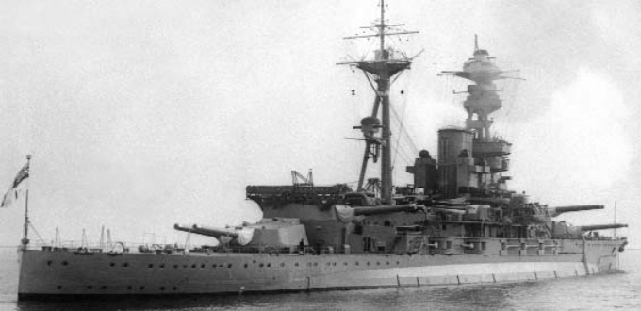
Briggs Marine is currently in the process of upgrading its in-house diver operated ‘hot tap’ equipment to make it suitable for ROV operations. This capability will provide, effective and efficient ‘hot tap’ access, to any polluting wreck within the continental shelf. Briggs’ broad footprint and strong environmental section complements its salvage service; ensuring safety, efficiency and environmental protection, remains the focus of the group’s operations.

Briggs Marine has added marine and environmental wreck salvage to its portfolio of services. Investment in adding this service consolidates the company’s approach to providing a total marine solution to its customers. Briggs’ diverse fleet of platforms and lifting capability provide flexible, cost effective, salvage, towing and environmental response operations.

Briggs Marine will be conducting a presentation on legacy wrecks and their potential to pollute. The presentation will include a case study of HMS Royal Oak oil removal program, conducted by Briggs Marine, in support of the MoD. HMS Royal Oak was a Sovereign class battle-ship that had been through the Battle of Jutland, she was sunk in the Scapa Flow at the beginning of WW2, claiming the lives of 833 sailors. Scapa Flow is an environmentally sensitive area. To date over 1500 tons of heavy fuel oil has been removed from the wreck.

This presentation is scheduled to take place on Tuesday 12th May at 2.50 pm in the Commercial Presentations Area in the Exhibition Area (lower level).

Get the ISCO Newsletter every week at no cost

This is a special Interspill edition of the ISCO Newsletter being published this week only in hard copy as well as the usual electronic version. You can receive your own personal copy every week via email. The ISCO Newsletter is focused on international, regional and national news that is of interest to professionals, companies and organisations involved in oil and chemical spill control, and the emerging field of CBRN incident response. Through the Newsletter and its other activities, ISCO is disseminating information on new developments – technical advances, legislation, events and other matters that affect the international spill response community. To receive the ISCO Newsletter regularly all you need to do is to send an email to info@spillcontrol.org with your name, email address and specify the country in which you live.

Legal disclaimer: Whilst ISCO takes every care to ensure that information published in this Newsletter is accurate, unintentional mistakes can occur. If an error is brought to our attention, a correction will be printed in the next issue of this Newsletter.

