THE T/B APEX 3508 SPILL IN THE MISSISSIPPI RIVER: A SUCCESSFUL SUNKEN OIL ASSESSMENT
An article contributed by Dr Jacqueline Michel, President of Research Planning, Inc. She is a geochemist with 36 years of experience in spill planning, response, and assessment. Much of her expertise has come from being part of the US National Oceanic and Atmospheric Administration's Scientific Support Team that is on 24-hr call to support the US Coast Guard nationwide, since 1978. Having worked in 33 countries, she has also extensive international experience and has worked in many different coastal and marine environments. One of her areas of special interest is in the behavior and fate of submerged and sunken oils, having responded to spills where some or all of the oil did not float since 1991.

On 2 September 2015, a collision occurred between northbound and southbound barges on the Lower Mississippi River near Columbus KY, resulting in a complete breach of the #3 starboard cargo tank on the T/B Apex 3508. Approximately 2,870 barrels of clarified slurry oil were discharged into the Mississippi River in the vicinity of mile marker 937. A sample of the slurry oil had a specific gravity of 1.14 (API of -7.4) and a viscosity of 160,000 centistokes (it was almost the consistency of peanut butter), thus the oil was expected to sink as a cohesive mass. No oil was observed on the water surface or on shorelines up to 16 km downriver from the collision area; an overflight conducted 1-2 days after the incident only showed light on-water sheening in isolated locations.

A technical workgroup was mobilized to identify and determine the extent of any sunken oil on the riverbed, which was mostly sand. An initial side-scan sonar (SSS) survey was conducted by local authorities, utilizing a vessel of opportunity and an off-the-shelf sonar system operated in 450 kHz mode; this preliminary survey indicated areas with anomalously low acoustic backscatter in the vicinity of the collision location. A diver survey and snare/pom-pom drags were subsequently conducted in the same area and confirmed the presence of sunken oil on the river bottom in the anomaly areas.

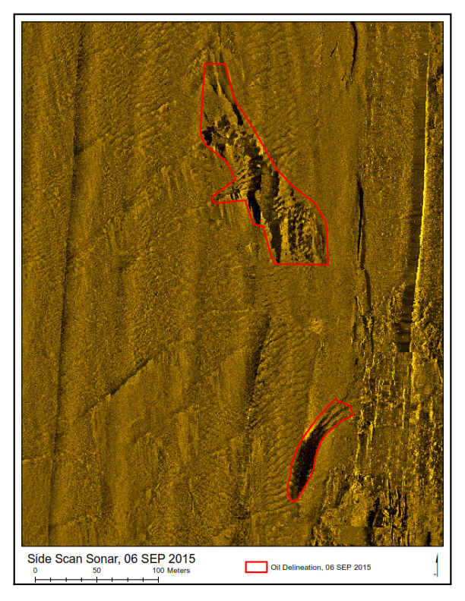
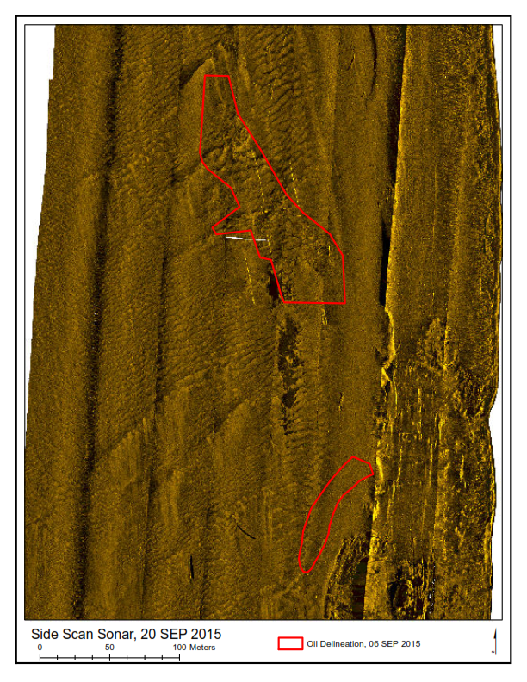

Figure 1. Side scan sonar backscatter imagery on: 6 September 2015 showing the sunken oil (as black areas of low backscatter) in the two areas delineated; and 20 September 2015 to document oil removal to the cleanup endpoints in the northern area. The southern spread of the sunken oil in the northern area can be seen on this image. By 20 September, the southern area had been covered by a thin layer of sediment.

Additional surveys were then conducted with the 450 kHz sonar system to better delineate the bottom anomalies and to identify any additional anomalies; no other anomalies were detected up to 10 km downstream of the incident location. The sunken oil assessment team then developed more detailed assessment plans for the focused operations zone enclosing the SSS anomalies. Geophysical surveys were conducted using a commercial survey vessel with a 445 kHz SSS and multibeam echosounder, generating high-resolution backscatter and bathymetry that served as a base map for sunken oil recovery planning and operations. The sunken oil occurred in two areas: the northern area (7,850 m2) near the collision site and the southern area (789 m2) where the barge was lightered. Both areas of sunken oil were removed using an environmental clamshell dredge. There was some downstream migration of the oil in the northern area, so removal operations were extended there. Side scan sonar surveys were repeated after removal to determine compliance with the clean-up endpoint no more than 10% observable oil. All treated areas met these endpoints. In all, 1,730 m3 of solids were removed, and the response ended on 25 September 2015. This spill demonstrated how sonar data (both backscatter and bathymetry) can be a valuable tool in a response where the oil sinks.

Prepared by Jacqueline Michel, Research Planning, Inc. This work was conducted as part of the Scientific Support Team to the U.S. Coast Guard provided by the Emergency Response Division of the Office of Response and Restoration, National Oceanic and Atmospheric Administration. We want to acknowledge the work of the many responders who contributed to this response.

