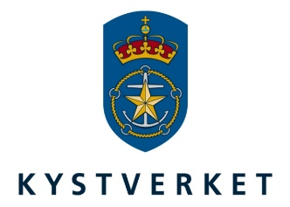
NEW TECHNOLOGY REDUCES ENVIRONMENTAL
IMPACT FROM OIL SPILLS
An article contributed by the Organisation of the Norwegian Coastal Administration.
The Norwegian Coastal Administration is an agency of the Norwegian Ministry of Transport and Communications responsible for services related to maritime safety, maritime infrastructure, transport planning and efficiency, and emergency response to acute pollution.
_____________________________________________________________________________________

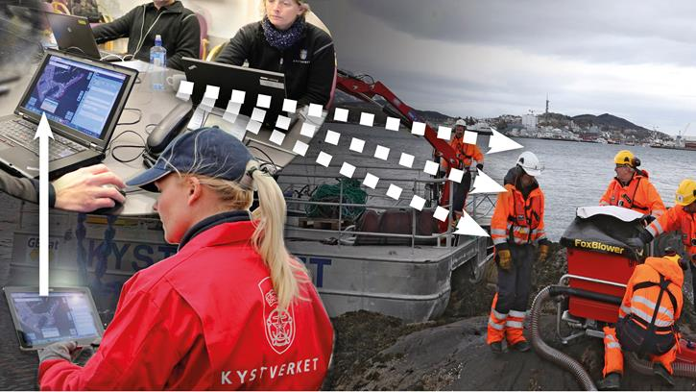

The new mapping solution provides registration in the field through a mobile application which immediately makes the data accessible for the operation managers. A common operation picture is established in real time. Illustration: NCA/M.Henriksen

The magnitude of the environmental impact from an oil spill occurrence is dependent on how quickly the clean-up begins. In order to streamline this process, the Norwegian Coastal Administration (NCA) has developed a new mapping solution for oil recovery operations.

Past: Notification of oil spill from stranded ships. Registration starts in the field with pen and paper and is then further processed by manually logging the data in map solution. This will at best be done the same evening, which in hand makes for a time-consuming process before a common operation picture is established.

Present: Notification of oil spill from stranded ships. The registration is done in the field through a mobile application which immediately makes the data accessible for the operation managers. A common operation picture is established in real time.

The time it takes from an oil spill occurs until the recovery process begins has been substantially minimized due to the development of the map-solution for preparedness. Project Manager and Senior Advisor at NCA, Simen Slotta, explain how oil spill recovery along the shore now can be mapped and managed more efficiently thanks to the new map-technology. The development project has been led by the NCA in close cooperation with the Norwegian Clean Seas Association for Operating Companies (NOFO).

“This new technology enables us to act faster, more efficient and with higher accuracy. It makes it possible to efficiently utilize the recovery resources in both tactical and operational management. In addition, we can reduce the environmental impact”.

Facts
- Web-map-solution based on the Adaptive technology
- Field-solution based on the Android-application Norgeskart
- Registry in field based on SCAT-methodic
- Access for offline use with local storage of background maps and data
- Unified registration in field with high precision - data snapped to the coastline
- Records of oil surcharges, images and video captured in the field synchronizes to server.

By introducing standardized objects and registration-forms that attaches to a detailed coastal contour, the new map-solution provides consistent and accurate data. Once the data is synchronized with the server, the information is accessible for all parties involved through the map-solution.

Facilitates and gives an overview

Senior Advisor Rune Bergstrøm at NCA has great expectations for the new technological solution. He believes it will facilitate the work of an oil spill response, help in planning the recovery, and make it easier to calculate the cost of the recovery.

“This will enable us to better prioritize when planning where to focus our efforts. At the same time it will give us a more accurate picture of ​​how much and how many meters of shoreline is contaminated. This will give us the necessary information for allocating our resources and estimating costs for recovery operations”, said Bergstrøm.

Faster communication-lines

He explains what the new map-based preparedness-solution means in practice for those who will take action when an oil spill occurs.

“We get new way of looking at the common operation picture if we were to have handled an operation the size of the one that came when Full City ran aground in 2009”, said Slotta.

He explains that based on lessons learned from major incidents of acute pollution in 2009 and 2011, NCA would look at what could be done to improve the tools that already existed. They saw that the map-solutions that were adopted during Full City in 2009, ‘Kystinfo’, provided an opportunity to digitize and report in a better way. One of the positive experiences was easier cooperation and communication between the parties involved.

Saw potential for development

“The challenge was that the necessary components to facilitate a field-solution were not in place. We still had to make notes on paper, at best at night. There was a delay between what was observed in the field and what was added to the solution. Additionally, the solution was not designed to register accurate recordings, but it did give a rough overview and was certainly helpful in the campaign, said Slotta. Additionally, the solution was not designed to register accurate recordings, but it did give a rough overview and was certainly helpful in the campaign”, said Slotta.

- Building common operation picture almost in real time
- Utilized agile development methodology - Scrum
- Partnership project between NCA and NOFO – see the project organization (norwegian)
The illustrations below show how an oil spill response was conducted in the past, while the last drawing shows the current desired line of events if an occurrence happened after the implementation of the new techonology – the data is recorded in the map-solution, then synchronized to a server, every party involved can quickly get the overview and allocate resources in near real time:
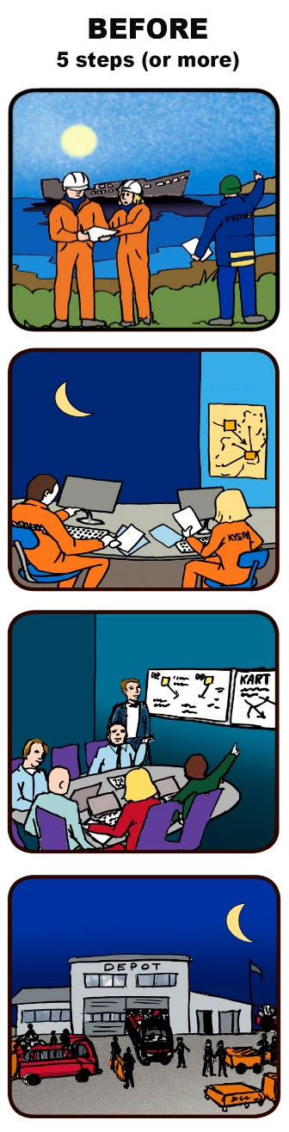

NCA saw the potential in developing a field-solution. After first checking if other nations had developed something similar, the innovation efforts to develop the map-solution begun. This was a collaborative effort between NCA and NOFO.

“We wanted to be able to collect data in real time from the field, and get it quickly over to those who coordinate response and recovery”, said the Senior Advisor.

Efficiency and precision

The new tools would consist of two main components with a clear goal: to quickly build common operation picture for the parties involved, be available for tablets and mobile - and eventually reduce the environmental impact of future oil spills.

The tools will provide greater efficiency and precision in the execution of oil-spill response and recovery operations.

“With ‘Strandappen’, which we call the mobile field solution, you can collect data in the field, take pictures and video, view oil surcharges, and quickly communicate this to the map-solution”, said Slotta.

User-involvement

A test-team of experienced people from both the Godafoss- and the Full City-operation has ensured broad involvement from the users during this development process.

“NCA has a good spatial data infrastructure. In the development of this map solution, we got back what we put in; in terms of the resources we've invested. The only thing that remains is the implementation of the solutions”, said Slotta.

The big test of the new technology is to take place this fall, when they are intended to be used in a major emergency exercise. Slotta also see growth potential in the new solutions.

“I imagine that we can integrate more seamless data and services from aircraft and satellite in the map solution”, says the project leader.

NCA in front

NCA has already received feedback that the so-called ‘Strandapp’ is impressive. This was received when the US Coast Guards signed cooperation on oil spill operations with NCA in the autumn of 2014:

"The meeting with the US Coast Guard revealed that Coastal Administration in Norway has experience with, and knowledge about topics that partners will reap great benefit from accessing. It also turned out that the NCA has come furthest digitally, in relation to the development of a field-application that NCA now has developed" said preparedness director Johan Marius Ly.

The project group has from the NCA consisted of Stig Nordaas, Silje Berger and Hilde Dolva, while from NOFO Karl Henrik Bryne, Torger Reve and Kristin K. Husebye have contributed.

Slotta highlights a committed project-group as a very important factor in development.

“Without their commitment and practical-oriented customer focus, the newly developed solutions would not have been this good”, said Simen Slotta.

Illustrations: Kystverket/Marianne Henriksen

