RFA DARKDALE OIL REMOVAL PROJECT
Simon Valentine, Emergency Response Manager, Swire Emergency Response Services, Dubai, UAE, recounts the very challenging project to remove oil from the Royal Fleet Auxiliary offshore St. Helena in the South Atlantic
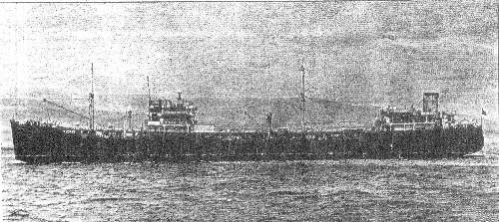
On 22nd October 1941, the RFA Refueling Tanker, RFA Darkdale was struck by three torpedoes while anchored 600 metres off of Jamestown, the capital of the remote South Atlantic Island of St Helena. The tanker sank and 41 lives were lost as a result. The Darkdale had been on station to replenish passing British Warships.

Since 1941, the wreck had leaked small amounts of oil sporadically, but as the wreck aged and deteriorated, it was recognised that the wreck presented an increasing threat to the environment. It was estimated that up to almost 5,000 cubic metres of oil remained onboard the tanker.

In 2013, the UK Ministry of Defence decided to issue a tender to qualified companies for the removal of the remaining oil from the RFA Darkdale, a challenging task for many reasons, not least due to the sensitive nature of the wreck as an official ‘Protected Place’, under the UK’s 1986 Protection of Military Remains Act or more commonly termed a ‘War Grave’.

Swire Salvage, part of the Emergency Response Division of Swire Pacific Offshore successfully won the tender. On 3rd June 2015, Pacific Dolphin, one of SPO’s new 6,600gt multi-purpose offshore vessel arrived in Cape Town, South Africa to begin preparations. Her arrival was followed shortly by another SPO vessel Pacific Supporter, both of which would play a significant role in the operations.

Through the next few weeks, Pacific Dolphin transformed from a mighty anchor handler to a ROV support, dive support and oil removal vessel. Equipment such as decompression chambers, ROV launch and recovery systems, dive launch and recovery systems, specialist medical equipment and oil removal tools were loaded onto the two large mezzanine decks that were fabricated to fit majority of the equipment. The task of de-oiling the Darkdale, was further complicated by the fact that St Helena has no airport
and is only reachable by vessel – everything required, including additional specialist personnel and divers, had to be carried onboard the two vessels. The 17 person crew was supplemented with an additional 20 specialists and divers.

The Pacific Supporter was loaded with oil spill response equipment including 600-m offshore boom, various skimmers, dispersant application systems and dispersant and temporary storage tanks from the Swire Emergency Response stockpile. In addition to this, equipment needed for the four anchor spread, which had to be fitted to ensure that the vessel could manoeuvre above the wreck while removing the oil was also loaded.

On 26th June, both Pacific Dolphin and Pacific Supporter set sail for St Helena. The trip lasted seven days and the vessels experienced the full wrath of the South Atlantic in winter. The two SPO vessels were also joined by the Golden Oak, a 8,500gt product tanker, that would act as the reception vessel for the recovered oil.

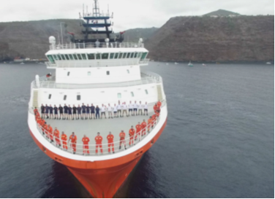
Photo on left - SPO’s vessel crew, with the dive team and project manager from UK MOD, on the deck of Pacific Dolphin

Upon their arrival, the vessels and all crew onboard received a warm welcome from the Harbour Master and customs officials of St Helena. They were also greeted by the UK Ministry of Defence’s Explosives and Ordinance Divers (EOD), who were tasked to remove 38 explosive shells from the wreck the following week to ensure that the area was safe for the Swire Salvage team to deploy their equipment.

After recovering and disposing all explosive ordinance successfully, the EOD formally handed the wreck site over to the Swire Salvage team, who could then safely deploy the equipment needed for the oil removal.

Phase 1, carried out in the first week, involved mapping out of the wreck. This was done by placing various subsea beacons around the wreck, which gave the team a clear indication of the position of the wreck. This was then translated into a scaled representation of the wreck, which could be marked out for the placement of the valves required for the oil removal.

Once a clear picture of the wreck was established, Pacific Supporter carefully positioned the four anchor spread which was then used to hold Pacific Dolphin in place, above the wreck.

Phase 2 commenced in the second week and this was essentially the cleaning of the hull followed by identifying and marking out the tanks that contained the fuel oil. As the Darkdale had been submerged for about 74 years, the team thought that the hull would have been damaged by years of corrosion. To the surprise of everyone involved, the wreck’s hull had maintained a thickness measuring in excess of 12mm.

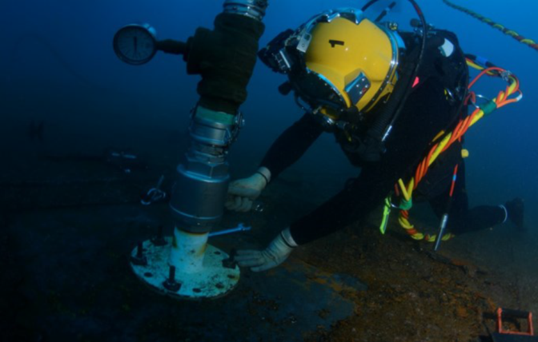
Photo on right: Swire Salvage Diver fitting one of the many valves on the RFA Darkdale

After cleaning and marking the affected area of the wreck, Swire Salvage team collaborated with the vessel’s crew to deploy the oil removal tool. Once deployed, the tool was then lowered to the hull to commence the drilling and valve fitting. This method, together with the diver fitted valves, was conducted over the following weeks until successfully completed.

Phase 3 involved hot tapping the wreck and took place over the fourth and fifth week. Started by the Swire Salvage team in collaboration with the UK MOD Salvage team, this was done using a specialised coring tool designed to drill through the valve into the hull of the wreck.

Once the valves had been hot tapped, specialised subsea pumps were fitted and the oil was pumped initially into the two mud tanks on Pacific Dolphin. Once these tanks were full, the oil was transferred via Pacific Supporter to the oil reception tanker, Golden Oak, which was chartered to provide storage facilities for the recovered oil.

On 12th August, the last of the tanks was successfully pumped out and duly signed off by the UK Ministry of Defence. A total of 1,263 cubic metres of Bunker Fuel Oil and 69 cubic metres of aviation fuel had been successfully removed from the wreck.

According to the UK MOD Salvage Director, Andy Liddell, “The team had extracted all the oil that can possibly be removed; we are now confident that St Helena is at no risk of environmental damage from a large spill, and that was our overriding objective.”

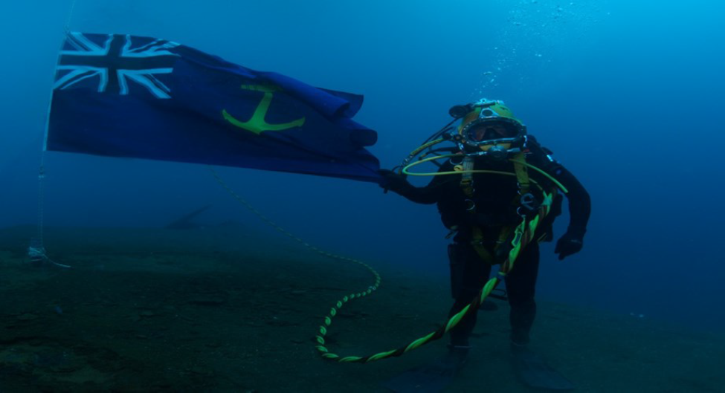

Above: RFA ensign placed on the wreck in remembrance of the sailors

Upon the completion of the oil removal phase, the Swire Salvage team then started the lengthy process of removing all the equipment from the wreck. Before Pacific Dolphin left the site, a RFA Ensign was placed on the wreck by the UK MOD divers as a sign of respect to the sailors who lost their lives on the vessel back in 1941
.
Having recovered all the subsea equipment and mooring spread, both vessels departed for Cape Town on 14th August. This project had been extremely challenging, but it was completed successfully and more importantly, safely. The successful completion of this project was commended by the Governor, Harbour Master, HM Customs and local media, and showcased SPO’s motto of ‘Excellence in Marine Services’. http://www.swire-ers.com

