15th International Effects of Oil on Wildlife Conference Unites Oiled Wildlife Response Community in Cape Town
By Jessica Slutter, Tri-State Bird Rescue & Research, Inc.
The Effects of Oil on Wildlife Conference (EOW) has been bringing together an international audience to advance the field of oiled wildlife response since 1982. The conference was co-founded by Tri-State Bird Rescue & Research, Inc. and International Bird Rescue; now each organization takes a turn as the primary planner of the conference, which is typically held every 3 years. Tri-State had the honor of planning the 15th EOW alongside the South African Foundation for the Conservation of Coastal Birds (SANCCOB) as the host organization in Cape Town, South Africa. After over a year and a half of planning efforts, the conference took place from 13-17 October. Roughly 120 delegates attended the conference from 6 continents and 20 countries, representing non-profit organizations, government agencies, and oil industry members.
The conference focused on two primary themes: the 25th anniversary of the MV Treasure oil spill response that affected over 20,000 African penguins as well as the critical conservation status of the African penguin species. The conference opened with an event honoring African Penguin Awareness Day, where African penguins rehabilitated by SANCCOB were released back into the wild by conference guests. The opening plenary session included a keynote address by conservationist Anton Wolfaardt highlighting his work to help save birds like African penguins from extinction. There was also a memorial exhibit on display created by a local South African artist to visually depict the events of the Treasure response and to honor the responders who contributed to the success of the event.
Delegates attended four days of presentations, panel discussions, roundtables, and workshops focusing on a wide range of topics related to oiled wildlife response, such as international collaboration, lessons learned from case studies, and alternative fuel responses. The conference closed out with field trips that allowed guests to explore some of the areas of South Africa that could be affected by oil spills, including a tour of the Cape of Good Hope and a birding trip to a gannet colony. On top of the knowledge shared and relationships formed, the conference also helped to generate funding for SANCCOB’s important work towards seabird conservation, largely thanks to sponsors such as Oil Spill Response Limited, the Global Oiled Wildlife Response System, and ExxonMobil. Follow the EOW Facebook page for updates regarding the next conference and learn more about SANCCOB’s conservation efforts at https://sanccob.co.za/.
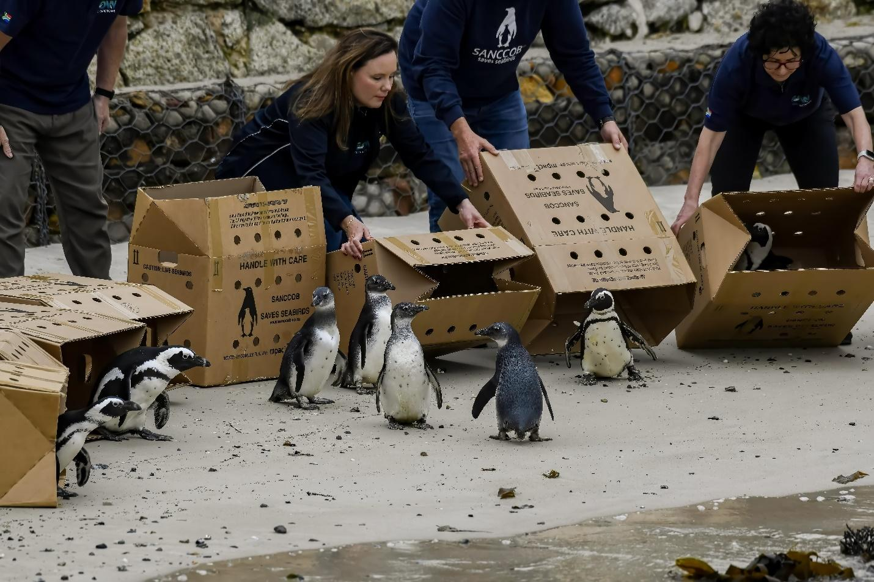
Conference guests releasing African penguins rehabilitated by SANCCOB back into the wild.
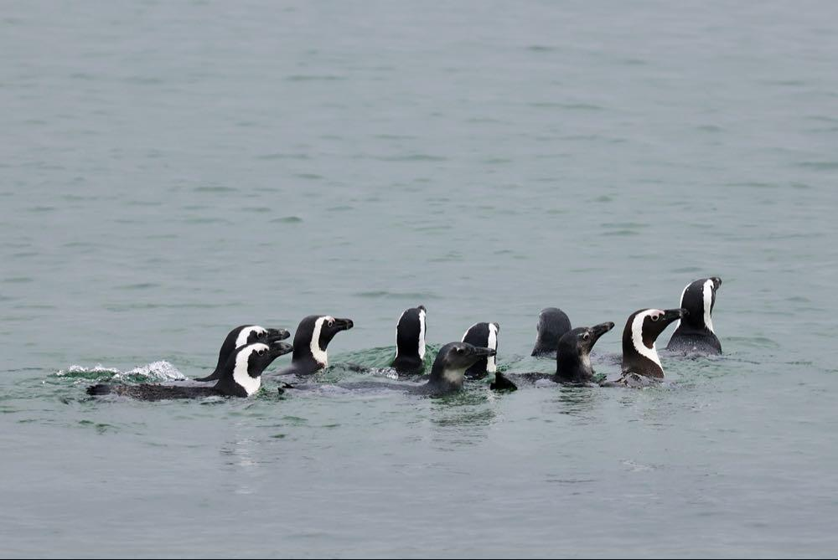
The group of rehabilitated African Penguins swimming away after being released at the African Penguin Awareness Day event.
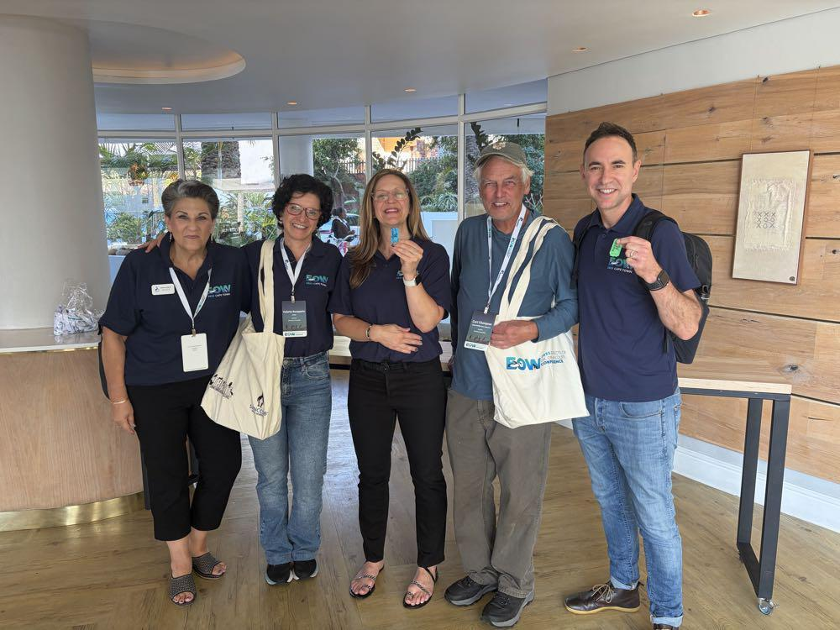
Members of the EOW Steering Committee pose for a photo.
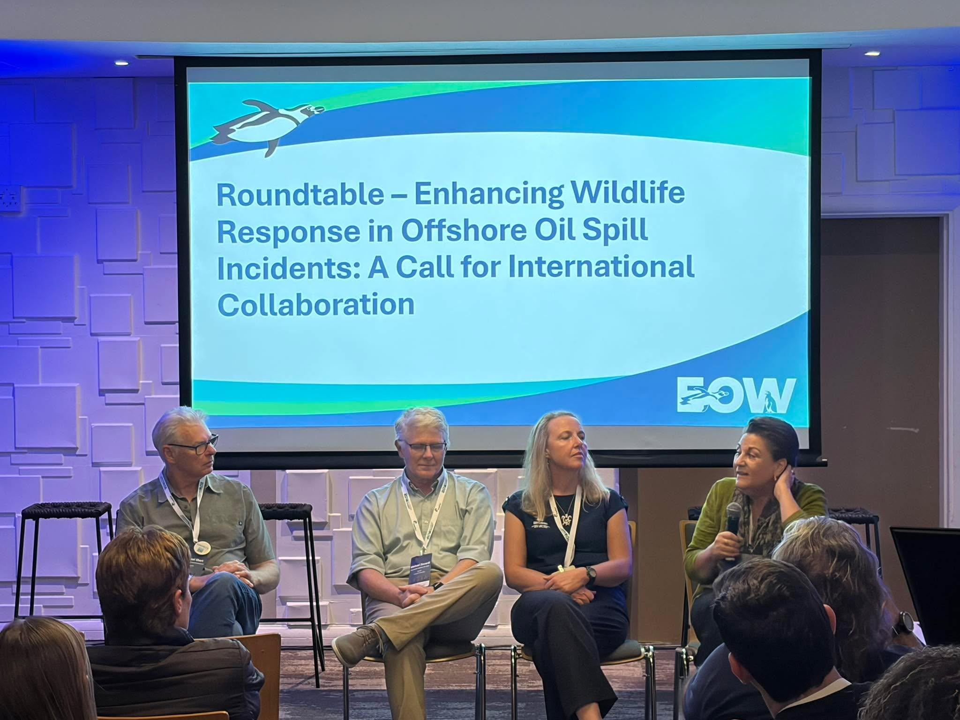
One of the roundtable discussions highlighting the importance of international collaboration.
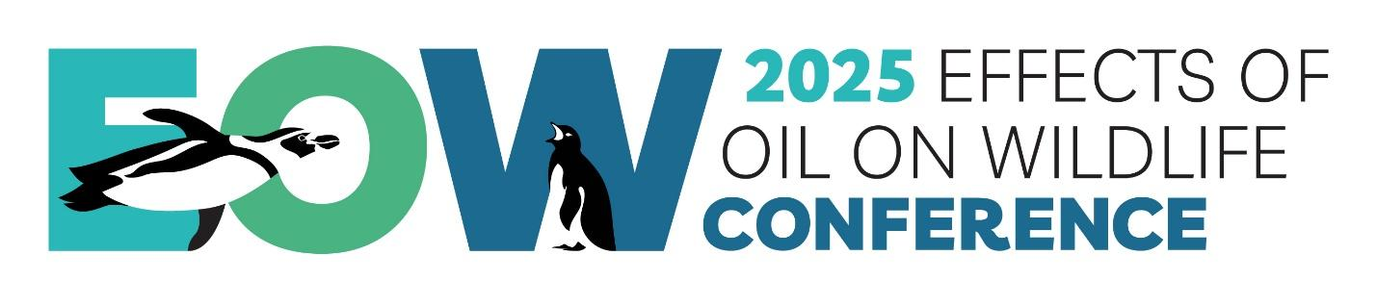
EOW logo

.
The Assembly of the International Maritime Organization (IMO) will meet for its 34th regular session from 24 November to 3 December 2025, to elect Members of the IMO Council and approve the Organization’s work programme and budget.
The Assembly is the highest Governing Body of the IMO, consisting of all Member States. The Assembly session will be preceded by the 135th session of the IMO Council (19-21 November). The IMO Assembly is open to all 176 Member States and three Associate Members. Observers from accredited organizations also attend.
Election of Council
The Assembly, which meets every two years in regular sessions, elects the forty Members of the Council. The Council is the Executive Organ of IMO and is responsible, under the Assembly, for supervising the work of the Organization.
A new 40-Member IMO Council for the 2026-2027 biennium will be elected, including:
Category (a): 10 States with the largest interest in providing international shipping services
Category (b): 10 States with the largest interest in international seaborne trade
Category (c): 20 States not elected under (a) or (b) above, which have special interests in maritime transport or navigation, to ensure representation of all major geographic areas of the world.
The candidates for the election are listed here. The election will take place on Friday 28 November, with an in-person, secret ballot.
The newly elected Council will meet on 4 December (for the Council’s 136th session) and will elect its Chair and Vice-Chair.
Strategic plan, budget and work programme
The Assembly is expected to adopt the revised Strategic Plan for the six-year period 2024 to 2029 and the Organization's budget and work programme for 2026 and 2027.
IMO Awards Ceremony
IMO will host the IMO Awards Ceremony on the evening of the first day of the Assembly, 24 November from 5.00pm. The event will be held at IMO Headquarters in London, and will include the presentation of:
International Maritime Prize for 2024 ·
2025 IMO Honours for Exceptional Bravery at sea
More details can be found here.
Other resolutions
The Assembly will adopt several resolutions on key aspects of the Organization's work, including those covering:
IMO Capacity Development Strategy
Procedures for port State control, 2025
Survey Guidelines under the Harmonized System of Survey and Certification (HSSC), 2025
2025 Non-exhaustive list of obligations under instruments relevant to the IMO Instruments Implementation Code (III Code)
Framework and procedures for the IMO Member State Audit Scheme
Code on Alerts and Indicators, 2025
Criteria for the provision of mobile satellite communication systems in the global maritime distress and safety system (GMDSS)
Charges for distress, urgency and safety communications through recognized mobile satellite services in the GMDSS
Consolidated Text of the Convention on the International Maritime Organization
Progressive use of Arabic as a working language of the Organization
Criteria and procedures for live streaming to the public of IMO Assembly plenary meetings
Rules of Procedure of the Assembly
Relations with non-governmental organizations
Follow online Plenary sessions will be livestreamed on IMO's Youtube Channel. The election of the Council will be held in person, via secret ballot and will not be livestreamed. Results will be shared via IMO on X and on the IMO website.
For more details about the meeting and FAQs, see - PREVIEW: IMO Assembly, 34th session, 24 November – 3 December 2025

